| **EXERCISE NO:4**  **DATE:06/02/2025** | **IMAGE FILTERING** |
| --- | --- |

**AIM:**

To implement various image processing techniques using OpenCV, including image reading, color space conversions, histogram equalization, manual grayscale conversion, histogram calculation, and image resizing, to enhance and analyze images effectively.

**NATURE IMAGE**

**ALGORITHM:**

1. Import OpenCV and necessary libraries
2. Read Image → cv2.imread()
3. Convert BGR to RGB → cv2.cvtColor(image, cv2.COLOR_BGR2RGB)
4. Display RGB Image
5. Convert RGB to Grayscale → cv2.cvtColor(image, cv2.COLOR_RGB2GRAY)
6. Manual RGB to Grayscale Conversion → Compute weighted sum of channels
7. Histogram Equalization
8. Using cv2.equalizeHist()
9. Compute manually using CDF table
10. Histogram Calculation
11. Using np.ravel() and cv2.calcHist()
12. Resize Image → cv2.resize(image, (width, height))

**CODE:**

import cv2

import matplotlib.pyplot as plt

import numpy as np

image = cv2.imread("Downloads/cv2.jpg")

image_rgb= cv2.cvtColor(image,cv2.COLOR_BGR2RGB)

plt.title("original image")

plt.imshow (image_rgb)

plt.axis ("off")

plt.show ()

**OUTPUT:**

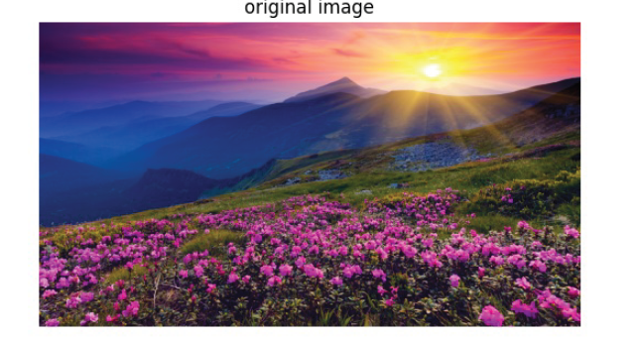

**CODE:**

image_gray = cv2.cvtColor(image,cv2.COLOR_BGR2GRAY)

plt.title("Original Image")

plt.imshow(image_gray,cmap='gray')

plt.axis('off')

plt.show()

**OUTPUT:**

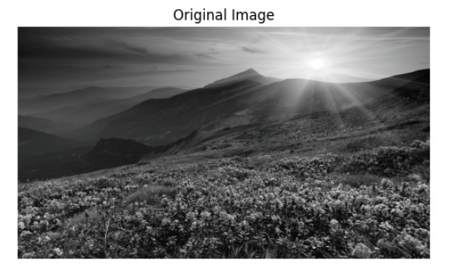

**IMAGE FILTERING:**

**CODE:**

def apply_filter(image, filter_mask):

if len(image.shape) == 3:

image = np.mean(image, axis=2)

image_height, image_width = image.shape

filter_height, filter_width = filter_mask.shape

pad_height, pad_width = filter_height // 2, filter_width // 2

padded_image = np.pad(image, ((pad_height, pad_height), (pad_width, pad_width)), mode='constant', constant_values

filtered_image = np.zeros_like(image, dtype=float)

for i in range(image_height):

for j in range(image_width):

region = padded_image[i:i + filter_height, j:j + filter_width]

filtered_image[i, j] = np.sum(region * filter_mask)

filtered_image = np.clip(filtered_image, 0, 255).astype(np.uint8)

return filtered_image

def median_filter(image, kernel_size=3):

assert kernel_size % 2 == 1

height, width = image.shape

pad = kernel_size // 2

padded_image = np.pad(image, pad, mode='constant', constant_values=0)

filtered_image = np.zeros_like(image)

# Apply median filtering

for i in range(height):

for j in range(width):

neighborhood = padded_image[i:i+kernel_size, j:j+kernel_size]

filtered_image[i, j] = np.median(neighborhood)

return filtered_image

#box_blur_filter = np.ones((5, 5)) / 25

mask_size = 25

box_blur_filter=np.ones((mask_size,mask_size),np.float32)/(mask_size*mask_size)

sharpening_filter = np.array([[ 0, -1, 0],

[-1, 5, -1],

[ 0, -1, 0]], dtype=np.float32)

# Apply sharpening filter to grayscale image

sharpened_image = apply_filter(image_gray, sharpening_filter)

smoothed_image_box = apply_filter(image_gray, box_blur_filter)

smoothed_image_median = median_filter(image_gray, kernel_size=25)

plt.figure(figsize=(12, 8))

plt.subplot(2, 3, 1)

plt.title("Original Image")

plt.imshow(image_gray, cmap='gray')

plt.axis('off')

plt.subplot(2, 3, 2)

plt.title("Smoothing (Box Blur)")

plt.imshow(smoothed_image_box,cmap='gray')

plt.axis('off')

plt.subplot(2, 3, 3)

plt.title("Sharpening Image (Laplacian)")

plt.imshow(sharpened_image, cmap='gray')

plt.axis('off')

plt.subplot(2, 3, 4)

plt.title("Smoothing (Median Filter)")

plt.imshow(smoothed_image_median, cmap='gray')

plt.axis('off')

plt.tight_layout()

plt.show()

**OUTPUT:**

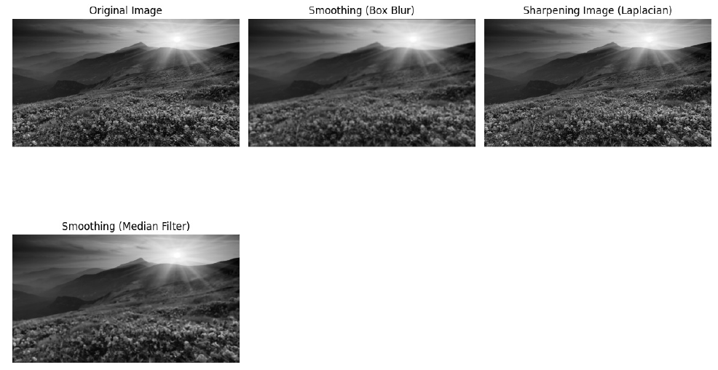

**CODE:**

plt.figure(figsize=(8, 4))

plt.subplot(2,3,1)

plt.hist(image_gray.ravel(),bins=256,range=(0,256),color='maroon')

plt.title("Original Image Histogram")

plt.xlabel("Pixel Values")

plt.ylabel("Frequency")

plt.subplot(2,3,2)

plt.hist(sharpened_image.ravel(),bins=256,range=(0,256),color='maroon')

plt.title("Sharpened Image Histogram")

plt.xlabel("Pixel Values")

plt.ylabel("Frequency")

plt.subplot(2,3,3)

plt.hist(smoothed_image_box.ravel(),bins=256,range=(0,256),color='maroon')

plt.title("Smoothed Box Image Histogram")

plt.xlabel("Pixel Values")

plt.ylabel("Frequency")

plt.subplot(2,3,4)

plt.hist(smoothed_image_median.ravel(),bins=256,range=(0,256),color='maroon')

plt.title("Median Filtered(Smoothed) Image Histogram")

plt.xlabel("Pixel Values")

plt.ylabel("Frequency")

plt.tight_layout()

plt.show()

**OUTPUT:**

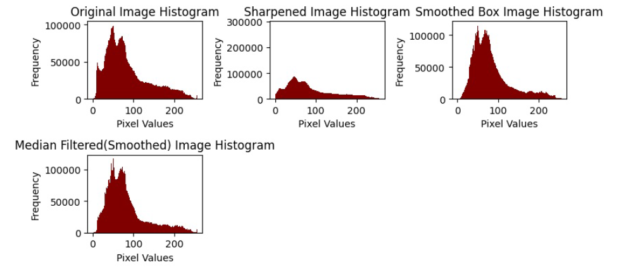

**CODE:**

dft = np.fft.fft2(image_gray)

dft_shift = np.fft.fftshift(dft)

magnitude_spectrum = 20*np.log(np.abs(dft_shift)+1)

plt.figure(figsize=(10,6))

plt.subplot(1,2,1)

plt.imshow(image_gray,cmap='gray')

plt.title("Original Image")

plt.axis('off')

plt.subplot(1,2,2)

plt.imshow(magnitude_spectrum,cmap='gray')

plt.title("Magnitude Spectrum (Frequency Domain)")

plt.axis('off')

plt.show()

**OUTPUT:**

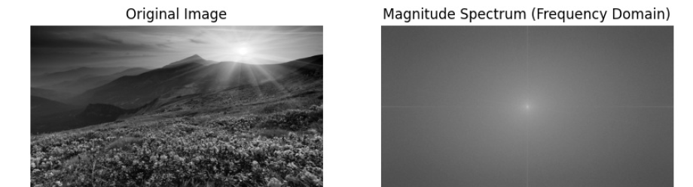

**CODE:**

shifted_image_add = np.clip(image_rgb + 50, 0, 255).astype(np.uint8) # Brighten

shifted_image_sub = np.clip(image_rgb - 50, 0, 255).astype(np.uint8)

plt.figure(figsize=(8,4))

plt.subplot(2,3,1)

plt.hist(image_rgb.ravel(),bins=256,range=(0,256),color='maroon')

plt.xlabel("Pixel Values")

plt.ylabel("Frequency")

plt.title("Original Image")

plt.subplot(2,3,2)

plt.hist(shifted_image_add.ravel(),bins=256,range=(0,256),color='maroon')

plt.xlabel("Pixel Values")

plt.ylabel("Frequency")

plt.title("Histogram of Shifted Image+50")

plt.subplot(2,3,3)

plt.hist(shifted_image_sub.ravel(),bins=256,range=(0,256),color='maroon')

plt.xlabel("Pixel Values")

plt.ylabel("Frequency")

plt.title(" Histogram of Shifted Image - 50")

plt.tight_layout()

plt.show()

**OUTPUT:**

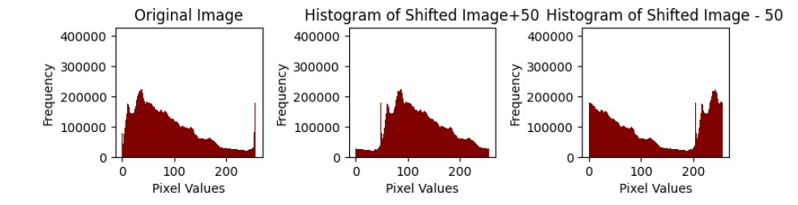

**CODE:**

plt.subplot(2,3,1)

plt.imshow(image_rgb)

plt.title("Original Image")

plt.axis('off')

plt.subplot(2,3,2)

plt.imshow(shifted_image_add)

plt.title("Shifted Image +50 ")

plt.axis('off')

plt.subplot(2,3,3)

plt.imshow(shifted_image_sub)

plt.title("Shifted Image - 50 ")

plt.axis('off')

plt.show()

**OUTPUT:**

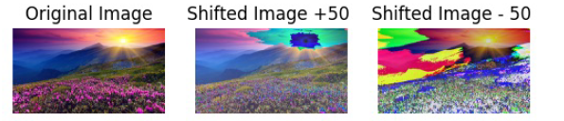

**CODE:**

I_min = np.min(image_gray)

I_max = np.max(image_gray)

stretched_image = np.clip(((image_gray - I_min) * 255) / (I_max - I_min), 0, 255).astype(np.uint8)

#stretched_image = contrast_stretch(image_gray)

plt.figure(figsize=(10,5))

plt.subplot(1,2,1)

plt.title("Original Image")

plt.imshow(image_gray,cmap='gray')

plt.axis("off")

plt.subplot(1,2,2)

plt.title("Contrast Stretched Image")

plt.imshow(stretched_image,cmap='gray')

plt.axis("off")

plt.tight_layout()

plt.show()

**OUTPUT:**

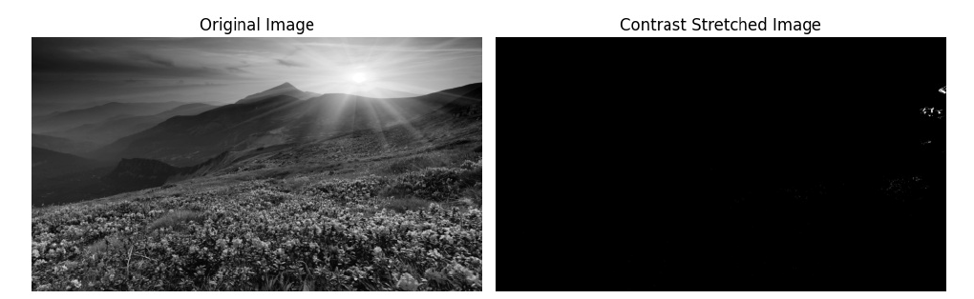

**CODE:**

plt.figure(figsize=(8,4))

plt.subplot(2,3,1)

plt.hist(image_gray.ravel(),bins=256,range=(0,256),color='maroon')

plt.xlabel("Pixel Values")

plt.ylabel("Frequency")

plt.title("Original Image")

plt.subplot(2,3,2)

plt.hist(stretched_image.ravel(),bins=256,range=(0,256),color='maroon')

plt.xlabel("Pixel Values")

plt.ylabel("Frequency")

plt.title("Histogram of Stretched Image")

**OUTPUT:**

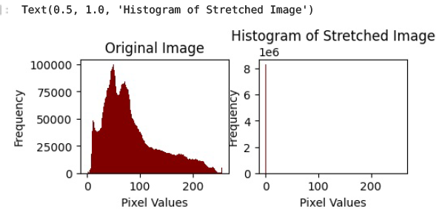

**CODE:**

threshold = 127

binary_image = np.zeros_like(image_gray,dtype=np.uint8)

binary_image[image_gray>threshold] = 255

plt.figure(figsize=(8, 4))

plt.subplot(1, 2, 1)

plt.title("Original Image")

plt.imshow(image_gray, cmap='gray')

plt.axis("off")

plt.subplot(1, 2, 2)

plt.title(f"Binary Image (Threshold = {threshold})")

plt.imshow(binary_image, cmap='gray')

plt.axis("off")

plt.tight_layout()

plt.show()

**OUTPUT:**

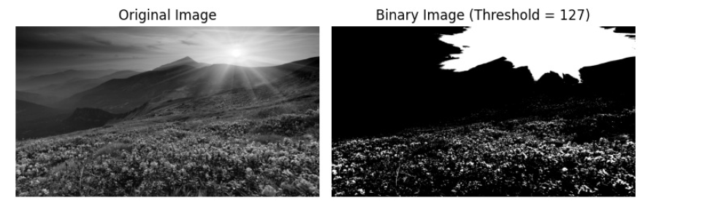

**CODE:**

image_negative = 255 - image_rgb

plt.subplot(1,2,1)

plt.imshow(image_rgb,cmap='gray')

plt.title("Original Image")

plt.axis('off')

plt.subplot(1,2,2)

plt.axis('off')

plt.title("Negative Image")

plt.imshow(image_negative,cmap='gray')

plt.show()

**OUTPUT:**

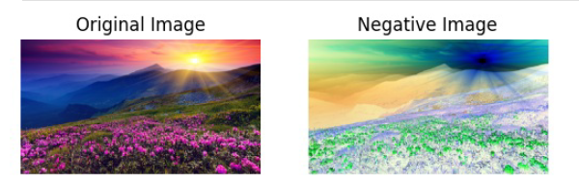

**CODE:**

plt.figure(figsize=(10,6))

plt.subplot(2,2,1)

plt.hist(image_rgb.ravel(),bins=256,range=(0,256),color='maroon')

plt.title("Original Image")

plt.xlabel("Pixel Values")

plt.ylabel("Frequency")

plt.subplot(2,2,2)

plt.hist(image_negative.ravel(),bins=256,range=(0,256),color='maroon')

plt.title("Negative Image")

plt.xlabel("Pixel Values")

plt.ylabel("Frequency")

#plt.tight_layout()

plt.show()

**OUTPUT:**

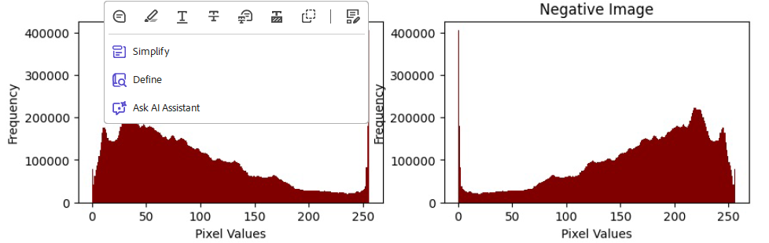

**RESULT:**

**We have successfully executed the code…**